Bill Clinton: 2004 Democratic National Convention Address

delivered 26 July 2004, Fleet Center, Boston

[AUTHENTICITY CERTIFIED: Text version below transcribed directly from audio.]
Hillary Clinton: I am very optimistic about this election because I think I know a great leader when I see one. And so does America. In 1992 and 1996, Americans chose a president who left our country in better shape than when he took office. And he still spends his days working to empower the powerless; to promote racial, religious, and ethnic reconciliation; to inspire young people to citizen service; and to bring life-saving medicines to people living with HIV-AIDS throughout the world. He showed Democrats how to win again and so will John Kerry. Please welcome the 42nd president of the United States, Bill Clinton!
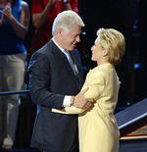
Bill Clinton: Thank you. Thank you very much. Thank you, ladies and gentlemen. Thank you. Calm down! Thank you. Thank you. Thank you. Thank you.
Ladies and gentlemen, I am honored to be here with you -- I am honored to share this podium with my Senator, Hillary Rodham Clinton, and I wanna thank the people of New York for giving the best public servant in my family a chance to continue serving the public. Thank you.
I am also -- I'm gonna say that again, in case you didn't hear it: I'm honored to be here tonight, and I wanna thank the people of New York for giving Hillary a chance to continue to serve in public life. I am very proud of her, and we are both very grateful to all of you, especially my good friends from Arkansas, for giving me the chance to serve in the White House for eight years.
I am honored to share this night with President Carter, for whom I worked in 1976 and who has inspired the world with his work for peace, democracy, and human rights. I am honored to share it with Al Gore, my friend and my partner for eight years, who played such a large role in building the prosperity and peace that we left America in 2000. And Al Gore, as he showed again tonight, demonstrated incredible patriotism and grace under pressure. He is the living embodiment of the principle that every vote counts, and this year we're gonna make sure they're all counted in every state in America.
My friends, after three conventions as a candidate or a President, tonight I come to you as a citizen, returning to the role that I have played for most of my life; as a foot soldier in our fight for the future as we nominate in Boston a true New England patriot for president. Now this state, who gave us in other times of challenge John Adams and John Kennedy, has given us John Kerry, a good man, a great senator, a visionary leader. And we are all here to do what we can to make him the next president of the United States.
My friends, we are constantly being told that America is deeply divided. But all Americans value freedom and faith and family. We all honor the service and sacrifice of our men and women in uniform in Iraq, Afghanistan, and throughout the world. We all want good jobs, good schools, health care, safe streets, a clean environment. We all want our children to grow up in a secure America, leading the world toward a peaceful and prosperous future.
Our differences are in how we can best achieve these things in a time of unprecedented change. Therefore, we Democrats will bring to the American people this year a positive campaign, arguing not who's a good or a bad person, but what is the best way to build the safe and prosperous world our children deserve.
The 21st century is marked by serious security threats, serious economic challenges, and serious problems, from AIDS to global warming to the continuing turmoil in the Middle East. But it also full of amazing opportunities -- to create millions of new jobs, and clean energy, and biotechnology; to restore our manufacturing base and reap the benefits of the global economy through our diversity and our commitment to decent labor and environmental standards for people all across the world; and to create a world where we can celebrate our religious, our racial, our ethnic, our tribal differences because our common humanity matters most of all.
To build that kind of world, we must make the right choices, and we must have a president who will lead the way. Democrats and Republicans have very different and deeply felt ideas about what choices we should make. They're rooted in fundamentally different views of how we should meet our common challenges at home and how we should play our role in the world.
We Democrats want to build a world and an America of shared responsibilities and shared benefits. We want a world with more global cooperation, where we act alone only when we absolutely have to. We think the role of government should give -- should be to give people the tools and to create the conditions to make the most of their own lives, and we think everybody should have that chance.
On the other hand, the Republicans in Washington believe that America should be run by the "right" people -- their people -- in a world in which America acts unilaterally when we can and cooperates when we have to. They believe the role of government is to concentrate wealth and power in the hands of those who embrace their economic, political, and social views, leaving ordinary citizens to fend for themselves on important matters like health care and retirement security. Now since most Americans aren't that far to the right, our friends have to portray us Democrats as simply unacceptable, lacking in strength and values; in other words, they need a divided America. But we don't.
Americans -- Americans long to be united. After 9/11, we all just wanted to be one nation. Not a single American on September the 12th, 2001 cared who won the next presidential election. All we wanted to do was to be one country, strong in the fight against terror, helping to heal those who were wounded and the families of those who lost their loved ones, reaching out to the rest of the world so we could meet these new challenges and go on with our democratic way of life.
The president had an amazing opportunity to bring the country together under his slogan of compassionate conservatism, and to unite the world in the struggle against terror.
Instead, he and his congressional allies made a very different choice. They chose to move that -- to use that moment of unity to try to push the country too far to the right and to walk away from our allies, not only in attacking in Iraq before the weapons inspectors had finished their work but in withdrawing American support for the climate change treaty and for the international court on war criminals and from the Anti-Ballistic Missile Treaty and from the Nuclear Test Ban Treaty.
Now -- now, at a time when we're trying to get other people to give up nuclear and biological and chemical weapons, they are trying to develop two new nuclear weapons, which they say we might use first.
At home -- at home, the president and the Republican Congress have made equally fateful choices, which they also deeply believe in. For the first time when America was on a war footing in our whole history, they gave two huge tax cuts, nearly half of which went to the top 1 percent of us.
Now, I'm in that group for the first time in my life. And you might remember that when I was in office, on occasion, the Republicans were kind of mean to me. But soon as I got out and made money, I began part of the most important group in the world to them. It was amazing. I -- I never thought I'd be so well cared for by the president and the Republicans in Congress.
I, uh, -- I almost sent them a thank-you note for my tax cuts -- until I realized that the rest of you were paying for the bill for it, and then I thought better of it.
Now, look at the choices they made, choices they believed in. They chose to protect my tax cut at all costs, while withholding promised funding for the Leave No Child Behind Act, leaving 2.1 million children behind. While they chose to protect my tax cut, while cutting 140,000 unemployed workers out of their job-training programs, a hundred thousand working families out of their child-care assistance, and worst of all, while cutting 300,000 poor children out of their after-school programs when we know it keeps them off the streets, out of trouble, in school learning, going to college and having a good life.
They chose -- they chose to protect my tax cuts while dramatically raising the out-of-pocket costs of health care to our veterans, and while weakening or reversing very important environmental measures that Al Gore and I put into place, everything from clean air to the protection of our forests.
Now, in this time, everyone in America had to sacrifice except the wealthiest Americans. And most of us, all most all of us, from Republicans to Independents and Democrats, we wanted to be asked to do our part too, but all they asked us to do was to expend the energy necessary to open the envelopes containing our tax cuts.
Now, if you like these choices and you agree with them, you should vote to return them to the White House and the Congress. If not, take a look at John Kerry, John Edwards, and the Democrats.We've got a different economic policy.
In this year's budget -- in this year's budget, the White House this year wants to cut off all the federal funding for 88,000 uniformed police officers under the COPS program we've had for 10 years. Among those 88,000 police are more than 700 members of the New York Police Department who put their lives on the line on 9/11. With gang violence rising and with all of us looking for terrorists in our midst and hoping they're not too well armed or too well dangerous -- too dangerous, the president and the Congress are about to allow the 10-year-old ban on deadly assault weapons to lapse.
Now, they believe it's the right thing to do, but our policy was to put more police on the street and to take assault weapons off the street, and it gave you eight years of declining crime and eight years of declining violence. Their policy is the reverse. They're taking police off the streets while they put assault weapons back on the street. Now if you agree with that choice, by all means vote to keep them in office. But if you don't, join John Kerry, John Edwards, and the Democrats in making America safer, smarter and stronger again.
On homeland security -- on homeland security, Democrats tried to double the number of containers at ports and airports checked for weapons of mass destruction. It cost a billion dollars. It would have been paid for under our bill by asking the 200,000 millionaires in America to cut their tax cut by 5000 dollars. Almost all 200,000 of us would like to have done that, to spend 5000 dollars to make all 300 million Americans feel safer. The measure failed. Why? Because the White House and the Republican leadership in the House of Representatives opposed it. They thought our 5000 dollars was more important than doubling the container checks at our ports and airports. If you agree with that, by all means reelect them. If not, John Kerry and John Edwards are your team for the future.
These policies have turned a projected 5.8 trillion dollar surplus that we left -- enough to pay for the baby-boomer retirement -- into a projected debt of almost 5 trillion dollars, with over 400 billion dollars in deficit this year and for years to come. Now, how do they pay for that deficit? First, by taking the Social Security surplus that comes in every month and endorsing the checks of working people over to me to pay for the tax cut. But it's not enough, so then they have to go borrow money. Most of it they borrow from the Chinese and the Japanese government. Sure these countries are competing with us for good jobs, but how can we enforce our trade laws against our bankers? I mean, come on.
So, if you think -- if you believe it is good policy, if you believe it is good policy to pay for my tax cuts with the Social Security checks of working men and women, and borrowed money from China and Japan, you should vote for them. If not, John Kerry's your man.
We Americans must choose for President -- we've got to choose for president between two strong men who both love their country, but who have very different world views: our nominee, John Kerry, who favors shared responsibility, shared opportunity, and more global cooperation; and their President and their party in Congress who favor concentrated wealth and power, leaving people to fend for themselves, and more unilateral action.
I think we're right for two reasons. First of all, America just works better when more people have a chance to live their dreams. And secondly, we live in an interdependent world in which we cannot possibly kill, jail, or occupy all our potential adversaries. So we have to both fight terror and build a world with more partners and fewer terrorists.
Now we tried it their way for 12 years. We tried it their way for 12 years. We tried it our way for eight years. Then we tried it their way for four more. By the only test that matters, whether people were better off when we finished than when we started, our way works better.
It produced over 22 million good jobs, rising incomes for the middle class -- over a hundred times as many people moved from poverty into the middle class -- more health care, the largest increase in college aid in 50 years, record homeownership, a cleaner environment, three surpluses in a row, a modernized defense force, strong efforts against terror, and a respected America in the world. It worked better.
More importantly -- more importantly, we have great new champions in John Kerry and John Edwards, two good men with wonderful wives: Teresa, a generous and wise woman who understands the world we're trying to shape; and Elizabeth, a lawyer and mother who understands the lives we're trying to lift.
Now let me tell you what I know about John Kerry. I've been seeing all the Republican ads about him. Let me tell you what I know about him. During the Vietnam War, many young men, including the current President, the Vice President and me, could have gone to Vietnam and didn't. John Kerry came from a privileged background. He could have avoided going, too. But instead he said, "Send me."
When -- when they sent those swift boats up the river in Vietnam, and they told them their job was to draw hostile fire, to wave the American flag and bait the enemy to come out and fight, John Kerry said, "Send me."
And then, on my watch, when it was time to heal the wounds of war and normalize relations with Vietnam and to demand an accounting of the POWs and MIAs we lost there, John Kerry said, "Send me."
Then, when we needed someone to push the cause of inner-city children struggling to avoid a life of crime, or to bring the benefits of high technology to ordinary Americans, or to clean the environment in a way that created new jobs, or to give small businesses a better chance to make it, John Kerry said, "Send me."
So tonight, my friends, I ask you to join me for the next 100 days in telling John Kerry's story, in promoting his ideas. Let every person in this hall and like-minded people all across our land say to him what he has always said to America: "Send me."
The bravery -- the bravery that men who fought by his side in battle, that bravery they saw in battle I have seen in politics. When I was President, John Kerry showed courage and conviction on crime, on welfare reform, on balancing the budget, at a time when those priorities were not exactly the way to win a popularity contest in our party. John Kerry took tough positions on tough problems. He knows who he is and where he's going. He has the experience, the character, the ideas, the values to be a great president. And in a time of change, he has two other very important qualities: an insatiable curiosity to understand the world around him and a willingness to hear other views, even those who disagree with him. Therefore, John Kerry will make choices that reflect both conviction and common sense. He proved that when he picked John Edwards to be his partner.
Now, everybody talks about John Edwards' energy and intellect and charisma. You know, I kind of resent him. But the important thing is not what talents he has, but how he has used them. He chose, he chose to use his talents to improve the lives of people like him who had to work for everything they've got, and to help people too often left out and left behind. And that's what he'll do as our Vice President.
Now their opponents will tell you -- their opponents will tell you we should be afraid of John Kerry and John Edwards because they won't stand up to the terrorists.
Don't you believe it: Strength and wisdom are not opposing values.
They go hand in hand.
They go hand in hand, and John Kerry has both. His first priority will be to keep America safe. Remember the Scripture, "Be not afraid." John Kerry and John Edwards are good people with good ideas, ideas to make the economy work again for middle class Americans, to restore fiscal responsibility, to save Social Security, to make health care more affordable and college more available, to free us from dependence on foreign oil and create new jobs with clean energy and a cleaner environment, to rally the world -- to rally the world to our side in the war against terror, and to make a world with more friends and less terror.
My friends, at every turning point in our history, we the people have chosen unity over division, heeding our founders' call to America's eternal mission to form a more perfect union, to widen the circle of opportunity, deepen the reach of freedom, and strengthen the bonds of our community. It happened every time because we made the right choices.
In the early days of the Republic, America was divided and at a crossroads, much as it is today, deeply divided over whether or not to build a real nation with a national economy and a national legal system. We chose to build a more perfect union.
In the Civil War, America was at another crossroads, deeply divided over whether to save the union and end slavery. We chose a more perfect union.
In the 1960s, when I was a young man, we were divided again over civil rights and women's rights. And again we chose to form a more perfect union.
As I said in 1992, I say again tonight: we are all in this together. We have an obligation both to work hard and to help our fellow citizens, an obligation both to fight terror and to build a world with more cooperation and less terror. Now, again, it is time to choose.
Since we're all in the same boat, we should choose a captain of our ship who is a brave, good man, who knows how to steer a vessel through troubled waters to the calm seas and the clear skies of our more perfect union. That is our mission! So let us join tonight and say to America in a loud, clear voice: "Send John Kerry!"
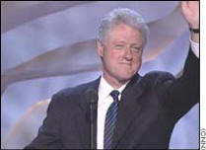
God bless you.

Martin Luther King, Jr.: "I Have a Dream"
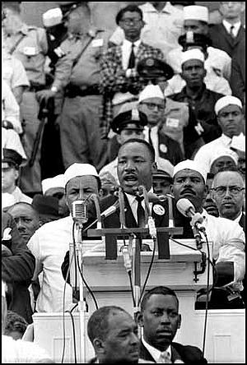
delivered 28 August 1963, at the Lincoln Memorial, Washington D.C.
[AUTHENTICITY CERTIFIED: Text version below transcribed directly from audio.]
I am happy to join with you today in what will go down in history as the greatest demonstration for freedom in the history of our nation.
Five score years ago, a great American, in whose symbolic shadow we stand today, signed the Emancipation Proclamation. This momentous decree came as a great beacon light of hope to millions of Negro slaves, who had been seared in the flames of withering injustice. It came as a joyous daybreak to end the long night of their captivity.
But one hundred years later, the Negro still is not free. One hundred years later, the life of the Negro is still sadly crippled by the manacles of segregation and the chains of discrimination. One hundred years later, the Negro lives on a lonely island of poverty in the midst of a vast ocean of material prosperity. One hundred years later, the Negro is still languished in the corners of American society and finds himself an exile in his own land. And so we've come here today to dramatize a shameful condition.
In a sense we have come to our nation's capital to cash a check. When the architects of our republic wrote the magnificent words of the Constitution and the Declaration of Independence, they were signing a promissory note to which every American was to fall heir. This note was a promise that all men, yes, black men as well as white men, would be guaranteed the unalienable rights of life, liberty, and the pursuit of happiness. It is obvious today that America has defaulted on this promissory note, insofar as her citizens of color are concerned. Instead of honoring this sacred obligation, America has given the Negro people a bad check, a check which has come back marked "insufficient funds."
But we refuse to believe that the bank of justice is bankrupt. We refuse to believe that there are insufficient funds in the great vaults of opportunity of this nation. And so we have come to cash this check, a check that will give us upon demand the riches of freedom and the security of justice.
We have also come to this hallowed spot to remind America of the fierce urgency of Now. This is no time to engage in the luxury of cooling off or to take the tranquilizing drug of gradualism. Now is the time to make real the promises of democracy. Now is the time to rise from the dark and desolate valley of segregation to the sunlit path of racial justice. Now is the time to lift our nation from the quicksands of racial injustice to the solid rock of brotherhood. Now is the time to make justice a reality for all of God's children.
It would be fatal for the nation to overlook the urgency of the moment. This sweltering summer of the Negro's legitimate discontent will not pass until there is an invigorating autumn of freedom and equality. Nineteen sixty-three is not an end but a beginning. Those who hope that the Negro needed to blow off steam and will now be content will have a rude awakening if the nation returns to business as usual. There will be neither rest nor tranquility in America until the Negro is granted his citizenship rights. The whirlwinds of revolt will continue to shake the foundations of our nation until the bright day of justice emerges.
But there is something that I must say to my people who stand on the warm threshold which leads into the palace of justice. In the process of gaining our rightful place we must not be guilty of wrongful deeds. Let us not seek to satisfy our thirst for freedom by drinking from the cup of bitterness and hatred. We must ever conduct our struggle on the high plane of dignity and discipline. We must not allow our creative protest to degenerate into physical violence. Again and again we must rise to the majestic heights of meeting physical force with soul force.
The marvelous new militancy which has engulfed the Negro community must not lead us to a distrust of all white people, for many of our white brothers, as evidenced by their presence here today, have come to realize that their destiny is tied up with our destiny. And they have come to realize that their freedom is inextricably bound to our freedom. We cannot walk alone.
And as we walk, we must make the pledge that we shall always march ahead. We cannot turn back. There are those who are asking the devotees of civil rights, "When will you be satisfied?" We can never be satisfied as long as the Negro is the victim of the unspeakable horrors of police brutality. We can never be satisfied as long as our bodies, heavy with the fatigue of travel, cannot gain lodging in the motels of the highways and the hotels of the cities. We cannot be satisfied as long as a Negro in Mississippi cannot vote and a Negro in New York believes he has nothing for which to vote. No, no, we are not satisfied and we will not be satisfied until justice rolls down like waters and righteousness like a mighty stream.
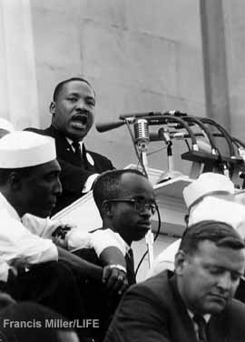
I am not unmindful that some of you have come here out of great trials and tribulations. Some of you have come fresh from narrow jail cells. Some of you have come from areas where your quest for freedom left you battered by the storms of persecutions and staggered by the winds of police brutality. You have been the veterans of creative suffering. Continue to work with the faith that unearned suffering is redemptive. Go back to Mississippi, go back to Alabama, go back to South Carolina, go back to Georgia, go back to Louisiana, go back to the slums and ghettos of our northern cities, knowing that somehow this situation can and will be changed. Let us not wallow in the valley of despair, I say to you today, my friends. And so even though we face the difficulties of today and tomorrow, I still have a dream. It is a dream deeply rooted in the American dream.
I have a dream that one day this nation will rise up and live out the true meaning of its creed: We hold these truths to be self-evident that all men are created equal.
I have a dream that one day on the red hills of Georgia the sons of former slaves and the sons of former slave owners will be able to sit down together at the table of brotherhood.
I have a dream that one day even the state of Mississippi, a state sweltering with the heat of injustice, sweltering with the heat of oppression, will be transformed into an oasis of freedom and justice.
I have a dream that my four little children will one day live in a nation where they will not be judged by the color of their skin but by the content of their character. I have a dream today!
I have a dream that one day, down in Alabama, with its vicious racists, with its governor having his lips dripping with the words of interposition and nullification; one day right down in Alabama little black boys and black girls will be able to join hands with little white boys and white girls as sisters and brothers. I have a dream today!
I have a dream that one day every valley shall be exalted, and every hill and mountain shall be made low, the rough places will be made plain, and the crooked places will be made straight, and the glory of the Lord shall be revealed and all flesh shall see it together.
This is our hope. This is the faith that I will go back to the South with. With this faith we will be able to hew out of the mountain of despair a stone of hope. With this faith we will be able to transform the jangling discords of our nation into a beautiful symphony of brotherhood. With this faith we will be able to work together, to pray together, to struggle together, to go to jail together, to stand up for freedom together, knowing that we will be free one day. And this will be the day, this will be the day when all of God's children will be able to sing with new meaning, "My country 'tis of thee, sweet land of liberty, of thee I sing. Land where my fathers died, land of the Pilgrim's pride, from every mountainside, let freedom ring!" And if America is to be a great nation, this must become true.
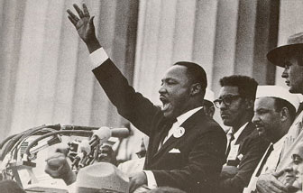
And so let freedom ring -- from the prodigious hilltops of New Hampshire.
Let freedom ring -- from the mighty mountains of New York.
Let freedom ring -- from the heightening Alleghenies of
Pennsylvania.
Let freedom ring -- from the snow-capped Rockies of Colorado.
Let freedom ring -- from the curvaceous slopes of California.
But not only that.
Let freedom ring -- from Stone Mountain of Georgia.
Let freedom ring -- from Lookout Mountain of Tennessee.
Let freedom ring -- from every hill and molehill of Mississippi,
from every mountainside, let freedom ring!
And when this happens, when we allow freedom to ring, when we let it ring from every village and every hamlet, from every state and every city, we will be able to speed up that day when all of God's children, black men and white men, Jews and Gentiles, Protestants and Catholics, will be able to join hands and sing in the words of the old Negro spiritual,
"Free at last, free at last.
Thank God Almighty, we are free at last."

Also in this database: Martin Luther King, Jr: A Time to Break Silence
Copyright Status: Audio = Used without permission. Text = Used without permission. Images of King = Used without permission. AmericanRhetoric.com does not own the copyrights to any of items on this page and has no legal authority to grant or deny permission for the use thereof. For further information on copyright permissions regarding text and audio reproductions of "I Have a Dream" see: http://www.stanford.edu/group/King/copyright/index.htm
Copyright Owner: Copyright inquiries and permission requests may be directed to:
Estate of Dr. Martin Luther King, Jr
Intellectual Properties Management
One Freedom Plaza
449 Auburn Avenue NE
Atlanta, GA 30312
Fax: 404-526-8969

John F. Kennedy: Inaugural Address
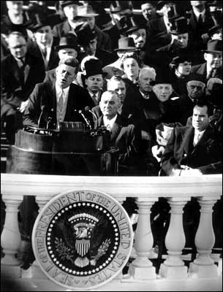
delivered January 20, 1961
[AUTHENTICITY CERTIFIED: Text version below transcribed directly from audio.]
Vice President Johnson, Mr. Speaker, Mr. Chief Justice, President Eisenhower, Vice President Nixon, President Truman, Reverend Clergy, fellow citizens:
We observe today not a victory of party but a celebration of freedom, symbolizing an end as well as a beginning, signifying renewal as well as change. For I have sworn before you and Almighty God the same solemn oath our forebears prescribed nearly a century and three-quarters ago.
The world is very different now. For man holds in his mortal hands the power to abolish all forms of human poverty and all forms of human life. And yet the same revolutionary beliefs for which our forebears fought are still at issue around the globe -- the belief that the rights of man come not from the generosity of the state but from the hand of God.
We dare not forget today that we are the heirs of that first revolution. Let the word go forth from this time and place, to friend and foe alike, that the torch has been passed to a new generation of Americans -- born in this century, tempered by war, disciplined by a hard and bitter peace, proud of our ancient heritage -- and unwilling to witness or permit the slow undoing of those human rights to which this nation has always been committed, and to which we are committed today at home and around the world.
Let every nation know, whether it wishes us well or ill, that we shall pay any price, bear any burden, meet any hardship, support any friend, oppose any foe to assure the survival and the success of liberty.
This much we pledge -- and more.
To those old allies whose cultural and spiritual origins we share, we pledge the loyalty of faithful friends. United there is little we cannot do in a host of cooperative ventures. Divided there is little we can do, for we dare not meet a powerful challenge at odds and split asunder.
To those new states whom we welcome to the ranks of the free, we pledge our word that one form of colonial control shall not have passed away merely to be replaced by a far more iron tyranny. We shall not always expect to find them supporting our view. But we shall always hope to find them strongly supporting their own freedom -- and to remember that, in the past, those who foolishly sought power by riding the back of the tiger ended up inside.
To those people in the huts and villages of half the globe struggling to break the bonds of mass misery, we pledge our best efforts to help them help themselves, for whatever period is required -- not because the communists may be doing it, not because we seek their votes, but because it is right.
If a free society cannot help the many who are poor, it cannot save the few who are rich.
To our sister republics south of our border, we offer a special pledge: to convert our good words into good deeds, in a new alliance for progress, to assist free men and free governments in casting off the chains of poverty. But this peaceful revolution of hope cannot become the prey of hostile powers. Let all our neighbors know that we shall join with them to oppose aggression or subversion anywhere in the Americas.
And let every other power know that this hemisphere intends to remain the master of its own house.
To that world assembly of sovereign states, the United Nations, our last best hope in an age where the instruments of war have far outpaced the instruments of peace, we renew our pledge of support -- to prevent it from becoming merely a forum for invective, to strengthen its shield of the new and the weak, and to enlarge the area in which its writ may run.
Finally, to those nations who would make themselves our adversary, we offer not a pledge but a request: that both sides begin anew the quest for peace -- before the dark powers of destruction unleashed by science engulf all humanity in planned or accidental self-destruction.
We dare not tempt them with weakness. For only when our arms are sufficient beyond doubt can we be certain beyond doubt that they will never be employed. But neither can two great and powerful groups of nations take comfort from our present course -- both sides overburdened by the cost of modern weapons, both rightly alarmed by the steady spread of the deadly atom, yet both racing to alter that uncertain balance of terror that stays the hand of mankind's final war. So let us begin anew -- remembering on both sides that civility is not a sign of weakness, and sincerity is always subject to proof.
Let us never negotiate out of fear. But let us never fear to negotiate.
Let both sides explore what problems unite us instead of belaboring those problems which divide us.
Let both sides, for the first time, formulate serious and precise proposals for the inspection and control of arms, and bring the absolute power to destroy other nations under the absolute control of all nations.
Let both sides seek to invoke the wonders of science instead of its terrors. Together let us explore the stars, conquer the deserts, eradicate disease, tap the ocean depths, and encourage the arts and commerce.
Let both sides unite to heed, in all corners of the earth, the command of Isaiah -- to "undo the heavy burdens . . . [and] let the oppressed go free."
And if a beachhead of cooperation may push back the jungle of suspicion, let both sides join in creating a new endeavor -- not a new balance of power, but a new world of law -- where the strong are just, and the weak secure, and the peace preserved.
All this will not be finished in the first one hundred days. Nor will it be finished in the first one thousand days; nor in the life of this Administration; nor even perhaps in our lifetime on this planet. But let us begin.
In your hands, my fellow citizens, more than mine, will rest the final success or failure of our course. Since this country was founded, each generation of Americans has been summoned to give testimony to its national loyalty. The graves of young Americans who answered the call to service surround the globe.
Now the trumpet summons us again -- not as a call to bear arms, though arms we need -- not as a call to battle, though embattled we are -- but a call to bear the burden of a long twilight struggle, year in and year out, rejoicing in hope, patient in tribulation, a struggle against the common enemies of man: tyranny, poverty, disease, and war itself.
Can we forge against these enemies a grand and global alliance, North and South, East and West, that can assure a more fruitful life for all mankind? Will you join in that historic effort?
In the long history of the world, only a few generations have been granted the role of defending freedom in its hour of maximum danger. I do not shrink from this responsibility -- I welcome it. I do not believe that any of us would exchange places with any other people or any other generation. The energy, the faith, the devotion which we bring to this endeavor will light our country and all who serve it. And the glow from that fire can truly light the world.
And so, my fellow Americans, ask not what your country can do for you; ask what you can do for your country.
My fellow citizens of the world, ask not what America will do for you, but what together we can do for the freedom of man.
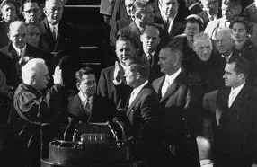
Finally, whether you are citizens of America or citizens of the world, ask of us here the same high standards of strength and sacrifice which we ask of you. With a good conscience our only sure reward, with history the final judge of our deeds, let us go forth to lead the land we love, asking His blessing and His help, but knowing that here on earth God's work must truly be our own.

Audio Source: Direct link to the John F. Kennedy Library
See also: John F. Kennedy: Houston Ministerial Association Speech

Franklin Delano Roosevelt: Pearl Harbor Address to the Nation
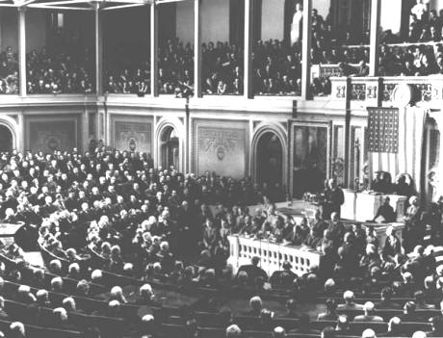
delivered on December 8, 1941
[AUTHENTICITY CERTIFIED: Text version below transcribed directly from audio.]
Mr. Vice President, Mr. Speaker, Members of the Senate, and of the House of Representatives:
Yesterday, December 7th, 1941 -- a date which will live in infamy -- the United States of America was suddenly and deliberately attacked by naval and air forces of the Empire of Japan.
The United States was at peace with that nation and, at the solicitation of Japan, was still in conversation with its government and its emperor looking toward the maintenance of peace in the Pacific.
Indeed, one hour after Japanese air squadrons had commenced bombing in the American island of Oahu, the Japanese ambassador to the United States and his colleagues delivered to our Secretary of State a formal reply to a recent American message. And while this reply stated that it seemed useless to continue the existing diplomatic negotiations, it contained no threat or hint of war or of armed attack.
It will be recorded that the distance of Hawaii from Japan makes it obvious that the attack was deliberately planned many days or even weeks ago. During the intervening time, the Japanese government has deliberately sought to deceive the United States by false statements and expressions of hope for continued peace.
The attack yesterday on the Hawaiian islands has caused severe damage to American naval and military forces. I regret to tell you that very many American lives have been lost. In addition, American ships have been reported torpedoed on the high seas between San Francisco and Honolulu.
Yesterday, the Japanese government also launched an attack against Malaya.
Last night, Japanese forces attacked Hong Kong.
Last night, Japanese forces attacked Guam.
Last night, Japanese forces attacked the Philippine Islands.
Last night, the Japanese attacked Wake Island.
And this morning, the Japanese attacked Midway Island.
Japan has, therefore, undertaken a surprise offensive extending throughout the Pacific area. The facts of yesterday and today speak for themselves. The people of the United States have already formed their opinions and well understand the implications to the very life and safety of our nation.
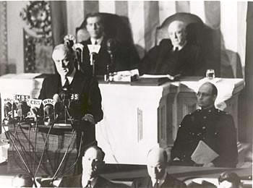
As commander in chief of the Army and Navy, I have directed that all measures be taken for our defense. But always will our whole nation remember the character of the onslaught against us.
No matter how long it may take us to overcome this premeditated invasion, the American people in their righteous might will win through to absolute victory.
I believe that I interpret the will of the Congress and of the people when I assert that we will not only defend ourselves to the uttermost, but will make it very certain that this form of treachery shall never again endanger us.
Hostilities exist. There is no blinking at the fact that our people, our territory, and our interests are in grave danger.
With confidence in our armed forces, with the unbounding determination of our people, we will gain the inevitable triumph -- so help us God.
I ask that the Congress declare that since the unprovoked and dastardly attack by Japan on Sunday, December 7th, 1941, a state of war has existed between the United States and the Japanese empire.

Ronald Reagan: The Space Shuttle "Challenger" Tragedy Address
"We'll continue our quest in space. There will be more shuttle flights...more volunteers, more civilians, more teachers in space."
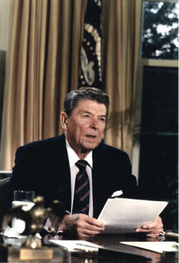
delivered 28 January 1986

[AUTHENTICITY CERTIFIED: Text version below transcribed directly from audio.]
Ladies and Gentlemen, I'd planned to speak to you tonight to report on the state of the Union, but the events of earlier today have led me to change those plans. Today is a day for mourning and remembering. Nancy and I are pained to the core by the tragedy of the shuttle Challenger. We know we share this pain with all of the people of our country. This is truly a national loss.
Nineteen years ago, almost to the day, we lost three astronauts in a terrible accident on the ground. But we've never lost an astronaut in flight. We've never had a tragedy like this. And perhaps we've forgotten the courage it took for the crew of the shuttle. But they, the Challenger Seven, were aware of the dangers, but overcame them and did their jobs brilliantly. We mourn seven heroes: Michael Smith, Dick Scobee, Judith Resnik, Ronald McNair, Ellison Onizuka, Gregory Jarvis, and Christa McAuliffe. We mourn their loss as a nation together.
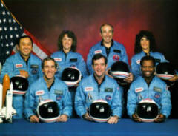
For the families of the seven, we cannot bear, as you do, the full impact of this tragedy. But we feel the loss, and we're thinking about you so very much. Your loved ones were daring and brave, and they had that special grace, that special spirit that says, "Give me a challenge, and I'll meet it with joy." They had a hunger to explore the universe and discover its truths. They wished to serve, and they did. They served all of us.
We've grown used to wonders in this century. It's hard to dazzle us. But for twenty-five years the United States space program has been doing just that. We've grown used to the idea of space, and, perhaps we forget that we've only just begun. We're still pioneers. They, the members of the Challenger crew, were pioneers.
And I want to say something to the schoolchildren of America who were watching the live coverage of the shuttle's take-off. I know it's hard to understand, but sometimes painful things like this happen. It's all part of the process of exploration and discovery. It's all part of taking a chance and expanding man's horizons. The future doesn't belong to the fainthearted; it belongs to the brave. The Challenger crew was pulling us into the future, and we'll continue to follow them.
I've always had great faith in and respect for our space program. And what happened today does nothing to diminish it. We don't hide our space program. We don't keep secrets and cover things up. We do it all up front and in public. That's the way freedom is, and we wouldn't change it for a minute.
We'll continue our quest in space. There will be more shuttle flights and more shuttle crews and, yes, more volunteers, more civilians, more teachers in space. Nothing ends here; our hopes and our journeys continue.
I want to add that I wish I could talk to every man and woman who works for NASA, or who worked on this mission and tell them: "Your dedication and professionalism have moved and impressed us for decades. And we know of your anguish. We share it."
There's a coincidence today. On this day three hundred and ninety years ago, the great explorer Sir Francis Drake died aboard ship off the coast of Panama. In his lifetime the great frontiers were the oceans, and a historian later said, "He lived by the sea, died on it, and was buried in it." Well, today, we can say of the Challenger crew: Their dedication was, like Drake's, complete.
The crew of the space shuttle Challenger honored us by the manner in which they lived their lives. We will never forget them, nor the last time we saw them, this morning, as they prepared for their journey and waved goodbye and "slipped the surly bonds of earth" to "touch the face of God."
Thank you.

Mary Church Terrell: "What It Means to be Colored in Capital of the United States"
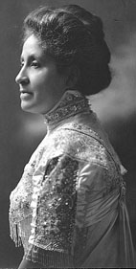
delivered 10 October 1906, United Women's Club, Washington, D.C.
Thank you very much.
Washington, D.C., has been called "The Colored Man's Paradise Whether." This sobriquet was given to the national capital in bitter irony by a member of the handicapped race, as he reviewed some of his own persecutions and rebuffs, or whether it was given immediately after the war by an ex-slaveholder who for the first time in his life saw colored people walking about like free men, minus the overseer and his whip, history saith not. It is certain that it would be difficult to find a worse misnomer for Washington than "The Colored Man s Paradise" if so prosaic a consideration as veracity is to determine the appropriateness of a name.
For fifteen years I have resided in Washington, and while it was far from being a paradise for colored people when I first touched these shores it has been doing its level best ever since to make conditions for us intolerable. As a colored woman I might enter Washington any night, a stranger in a strange land, and walk miles without finding a place to lay my head. Unless I happened to know colored people who live here or ran across a chance acquaintance who could recommend a colored boarding-house to me, I should be obliged to spend the entire night wandering about. Indians, Chinamen, Filipinos, Japanese and representatives of any other dark race can find hotel accommodations, if they can pay for them. The colored man alone is thrust out of the hotels of the national capital like a leper.
As a colored woman I may walk from the Capitol to the White House, ravenously hungry and abundantly supplied with money with which to purchase a meal, without finding a single restaurant in which I would be permitted to take a morsel of food, if it was patronized by white people, unless I were willing to sit behind a screen. As a colored woman I cannot visit the tomb of the Father of this country, which owes its very existence to the love of freedom in the human heart and which stands for equal opportunity to all, without being forced to sit in the Jim Crow section of an electric car which starts form the very heart of the city– midway between the Capital and the White House. If I refuse thus to be humiliated, I am cast into jail and forced to pay a fine for violating the Virginia laws....
As a colored woman I may enter more than one white church in Washington without receiving that welcome which as a human being I have the right to expect in the sanctuary of God. . .
Unless I am willing to engage in a few menial occupations, in which the pay for my services would be very poor, there is no way for me to earn an honest living, if I am not a trained nurse or a dressmaker or can secure a position as teacher in the public schools, which is exceedingly difficult to do. It matters not what my intellectual attainments may be or how great is the need of the services of a competent person, if I try to enter many of the numerous vocations in which my white sisters are allowed to engage, the door is shut in my face.
From one Washington theater I am excluded altogether. In the remainder certain seats are set aside for colored people, and it is almost impossible to secure others. . .
With the exception of the Catholic University, there is not a single white college in the national capitol to which colored people are admitted. . . . A few years ago the Columbian Law School admitted colored students, but in deference to the Southern white students the authorities have decided to exclude them altogether.
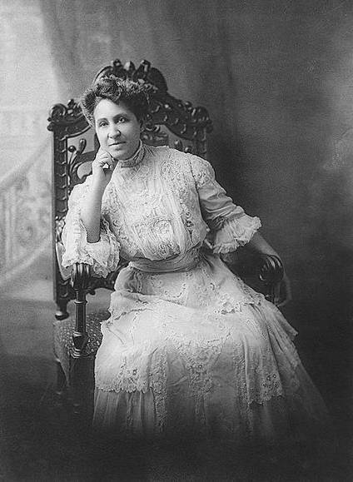
Some time ago a young woman who had already attracted some attention in the literary world by her volume of short stories answered an advertisement which appeared in a Washington newspaper, which called for the services of a skilled stenographer and expert typewriter. . . . The applicants were requested to send specimens of their work and answer certain questions concerning their experience and their speed before they called in person. In reply to her application the young colored woman. . . received a letter from the firm stating that her references and experience were the most satisfactory that had been sent and requesting her to call. When she presented herself there was some doubt in the mind of the man to whom she was directed concerning her racial pedigree, so he asked her point-blank whether she was colored or white.When she confessed the truth the merchant expressed. . . deep regret that he could not avail himself of the services of so competent a person, but frankly admitted that employing a colored woman in his establishment in any except a menial position was simply out of the question. . . .
Not only can colored women secure no employment in the Washington stores, department and otherwise, except as menials, and such positions, of course, are few, but even as customers they are not infrequently treated with discourtesy both by the clerks and the proprietor himself. . . .
Although white and colored teachers are under the same Board of Education and the system for the children of both races is said to be uniform, prejudice against the colored teachers in the public schools is manifested in a variety of ways. From 1870 to 1900 there was a colored superintendent at the head of the colored schools. During all that time the directors of the cooking, sewing, physical culture, manual training, music and art departments were colored people. Six years ago a change was inaugurated. The colored superintendent was legislated out of office and the directorships, without a single exception, were taken from colored teachers and given to the whites. . . .
Now, no matter how competent or superior the colored teachers in our public schools may be, they know that they can never rise to the height of a directorship, can never hope to be more than an assistant and receive the meager salary therefore, unless the present regime is radically changed....
Strenuous efforts are being made to run Jim Crow cars in the national capital. . . . Representative Heflin, of Alabama, who introduced a bill providing for Jim Crow street cars in the District of Columbia last winter, has just received a letter from the president of the East Brookland Citizens’ Association “indorsing the movement for separate street cars and sincerely hoping that you will be successful in getting this enacted into a law as soon as possible.” Brookland is a suburb of Washington.
The colored laborer’s path to a decent livelihood is by no means smooth. Into some of the trades unions here he is admitted, while from others he is excluded altogether. By the union men this is denied, although I am personally acquainted with skilled workmen who tell me they are not admitted into the unions because they are colored. But even when they are allowed to join the unions they frequently derive little benefit, owing to certain tricks of the trade. When the word passes round that help is needed and colored laborers apply, they are often told by the union officials that they have secured all the men they needed, because the places are reserved for white men, until they have been provided with jobs, and colored men must remain idle, unless the supply of white men is too small. . . .
And so I might go on citing instance after instance to show the variety of ways in which our people are sacrificed on the altar of prejudice in the Capital of the United States and how almost insurmountable are the obstacles which block his path to success. . . .
It is impossible for any white person in the United States, no matter how sympathetic and broad, to realize what life would mean to him if his incentive to effort were suddenly snatched away. To the lack of incentive to effort, which is the awful shadow under which we live, may be traced the wreck and ruin of score of colored youth. And surely nowhere in the world do oppression and persecution based solely on the color of the skin appear more hateful and hideous than in the capital of the United States, because the chasm between the principles upon which this Government was founded, in which it still professes to believe, and those which are daily practiced under the protection of the flag, yawn so wide and deep.

Margaret Sanger: "The Morality of Birth Control"
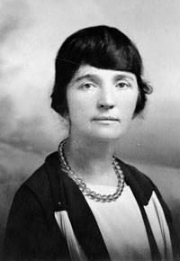
delivered 18 November 1921, Park Theatre, NY after the suppression by the New York Police of the Town Hall Meeting, Sunday Evening, November 13th
The meeting tonight is a postponement of one which was to have taken place at the Town Hall last Sunday evening. It was to be a culmination of a three day conference, two of which were held at the Hotel Plaza, in discussing the Birth Control subject in its various and manifold aspects.
The one issue upon which there seems to be most uncertainty and disagreement exists in the moral side of the subject of Birth Control. It seemed only natural for us to call together scientists, educators, members of the medical profession and the theologians of all denominations to ask their opinion upon this uncertain and important phase of the controversy. Letters were sent to the most eminent men and women in the world. We asked in this letter, the following questions:
1. Is over-population a menace to the peace of the world?
2. Would the legal dissemination of scientific Birth Control information through the medium of clinics by the medical profession be the most logical method of checking the problem of over-population?
3. Would knowledge of Birth Control change the moral attitude of men and women toward the marriage bond or lower the moral standards of the youth of the country?
4. Do you believe that knowledge which enables parents to limit the families will make for human happiness, and raise the moral, social and intellectual standards of population?
We sent such a letter not only to those who, we thought, might agree with us, but we sent it also to our known opponents. Most of these people answered. Every one who answered did so with sincerity and courtesy, with the exception of one group whose reply to this important question as demonstrated at the Town Hall last Sunday evening was a disgrace to liberty-loving people, and to all traditions we hold dear in the United States. I believed that the discussion of the moral issue was one which did not solely belong to theologians and to scientists, but belonged to the people. And because I believed that the people of this country may and can discuss this subject with dignity and with intelligence I desired to bring them together, and to discuss it in the open.
When one speaks of moral, one refers to human conduct. This implies action of many kinds, which in turn depends upon the mind and the brain. So that in speaking of morals one must remember that there is a direct connection between morality and brain development. Conduct is said to be action in pursuit of ends, and if this is so, then we must hold the irresponsibility and recklessness in our action is immoral, while responsibility and forethought put into action for the benefit of the individual and the race becomes in the highest sense the finest kind of morality.
We know that every advance that woman has made in the last half century has been made with opposition, all of which has been based upon the grounds of immorality. When women fought for higher education, it was said that this would cause her to become immoral and she would lose her place in the sanctity of the home. When women asked for the franchise it was said that this would lower her standard of morals, that it was not fit that she should meet with and mix with the members of the opposite sex, but we notice that there was no objection to her meeting with the same members of the opposite sex when she went to church.
The church has ever opposed the progress of woman on the ground that her freedom would lead to immorality. We ask the church to have more confidence in women. We ask the opponents of this movement to reverse the methods of the church, which aims to keep women moral by keeping them in fear and in ignorance, and to inculcate into them a higher and truer morality based upon knowledge. And ours is the morality of knowledge. If we cannot trust woman with the knowledge of her own body, then I claim that two thousand years of Christian teaching has proved to be a failure.
We stand on the principle that Birth Control should be available to every adult man and woman. We believe that every adult man and woman should be taught the responsibility and the right use of knowledge. We claim that woman should have the right over her own body and to say if she shall or if she shall not be a mother, as she sees fit. We further claim that the first right of a child is to be desired. While the second right is that it should be conceived in love, and the third, that it should have a heritage of sound health.
Upon these principles the Birth Control movement in America stands. When it comes to discussing the methods of Birth Control, that is far more difficult. There are laws in this country which forbid the imparting of practical information to the mothers of the land. We claim that every mother in this country, either sick or well, has the right to the best, the safest, the most scientific information. This information should be disseminated directly to the mothers through clinics by members of the medical profession, registered nurses and registered midwives.
Our first step is to have the backing of the medical profession so that our laws may be changed, so that motherhood may be the function of dignity and choice, rather than one of ignorance and chance. Conscious control of offspring is now becoming the ideal and the custom in all civilized countries. Those who oppose it claim that however desirable it may be on economic or social grounds, it may be abused and the morals of the youth of the country may be lowered. Such people should be reminded that there are two points to be considered. First, that such control is the inevitable advance in civilization. Every civilization involves an increasing forethought for others, even for those yet unborn. The reckless abandonment of the impulse of the moment and the careless regard for the consequences, is not morality. The selfish gratification of temporary desire at the expense of suffering to lives that will come may seem very beautiful to some, but it is not our conception of civilization, or is it our concept of morality.
In the second place, it is not only inevitable, but it is right to control the size of the family for by this control and adjustment we can raise the level and the standards of the human race. While Nature’s way of reducing her numbers is controlled by disease, famine and war, primitive man has achieved the same results by infanticide, exposure of infants, the abandonment of children, and by abortion. But such ways of controlling population is no longer possible for us. We have attained high standards of life, and along the lines of science must we conduct such control. We must begin farther back and control the beginnings of life. We must control conception. This is a better method, it is a more civilized method, for it involves not only greater forethought for others, but finally a higher sanction for the value of life itself.
Society is divided into three groups. Those intelligent and wealthy members of the upper classes who have obtained knowledge of Birth Control and exercise it in regulating the size of their families. They have already benefited by this knowledge, and are today considered the most respectable and moral members of the community. They have only children when they desire, and all society points to them as types that should perpetuate their kind.
The second group is equally intelligent and responsible. They desire to control the size of their families, but are unable to obtain knowledge or to put such available knowledge into practice.
The third are those irresponsible and reckless ones having little regard for the consequence of their acts, or whose religious scruples prevent their exercising control over their numbers. Many of this group are diseased, feeble-minded, and are of the pauper element dependent entirely upon the normal and fit members of society for their support. There is no doubt in the minds of all thinking people that the procreation of this group should be stopped. For if they are not able to support and care for themselves, they should certainly not be allowed to bring offspring into this world for others to look after. We do not believe that filling the earth with misery, poverty and disease is moral. And it is our desire and intention to carry on our crusade until the perpetuation of such conditions has ceased.
We desire to stop at its source the disease, poverty and feeble-mindedness and insanity which exist today, for these lower the standards of civilization and make for race deterioration. We know that the masses of people are growing wiser and are using their own minds to decide their individual conduct. The more people of this kind we have, the less immorality shall exist. For the more responsible people grow, the higher do they and shall they attain real morality.

American Rhetoric: Movie Speech
"A Beautiful Mind" (2002)
John Nash: 1994 Nobel Prize in Economic Sciences Acceptance Address
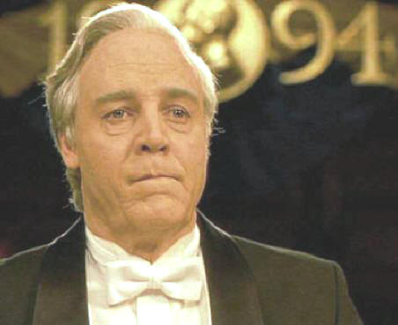
Nash: Thank you. I've always believed in numbers and the equations and logics that lead to reason.
But after a lifetime of such pursuits, I ask, "What truly is logic? Who decides reason?"
My quest has taken me through the physical, the metaphysical, the delusional -- and back.
And I have made the most important discovery of my career, the most important discovery of my life: It is only in the mysterious equations of love that any logic or reasons can be found.
I'm only here tonight because of you [his wife, Alicia].
You are the reason I am. You are all my reasons.
Thank you. (Merry Christmas, Noemi).
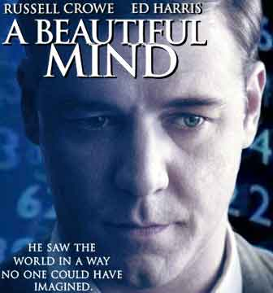
photo of Professor John Nash

American Rhetoric: Movie Speech
"Braveheart" (1995)
William Wallace: Address to Scottish Army at Stirling

Wallace: Sons of Scotland, I am William Wallace.
Young soldier: William Wallace is 7 feet tall.
Wallace: Yes, I've heard. Kills men by the hundreds, and if he were here he'd consume the English with fireballs from his eyes and bolts of lightning from his arse. I am William Wallace. And I see a whole army of my countrymen here in defiance of tyranny. You have come to fight as free men, and free men you are. What would you do without freedom? Will you fight?
Veteran soldier: Fight? Against that? No, we will run; and we will live.
Wallace: Aye, fight and you may die. Run and you'll live -- at least a while. And dying in your beds many years from now, would you be willing to trade all the days from this day to that for one chance, just one chance to come back here and tell our enemies that they may take our lives, but they'll never take our freedom!!!
Wallace and Soldiers: Alba gu bra! (Scotland forever!)


American Rhetoric: Movie Speech
"Field of Dreams" (1989)

Terrence Mann: "People Will Come"
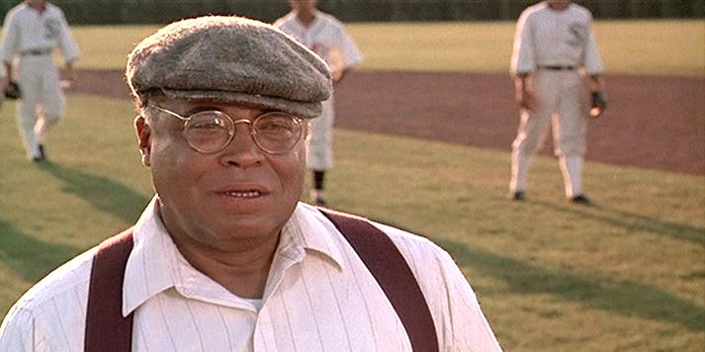
Audio mp3 delivered by James Earl Jones
Mann: Ray, people will come, Ray. They'll come to Iowa for reasons they can't even fathom. They'll turn into the driveway, not knowing for sure why they're doing it. They'll arrive at your door as innocent as children, longing for the past. "Of course we won't mind if you have a look around," you'll say. "It's only twenty dollars per person." They'll pass over the money without even thinking about it; for it is money they have and peace they lack.
Mark: Ray, just sign the papers.
Mann: And they'll like walk out to the bleachers, sit in shirt-sleeves on a perfect afternoon. They'll find they have reserved seats somewhere along one of the baselines, where they sat when they were children and cheered their heroes. And they'll watch the game, and it'll be as if they had dipped themselves in magic waters. The memories will be so thick they'll have to brush them away from their faces.
Mark: Ray, when the bank opens in the morning, they'll foreclose.
Mann: People will come, Ray.
Mark: You're broke, Ray. Sell now or you'll lose everything.
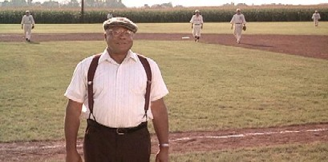
Mann: The one constant through all the years, Ray, has been baseball. America has rolled by like an army of steamrollers; it has been erased like a blackboard, rebuilt, and erased again. But baseball has marked the time. This field, this game, is a part of our past, Ray. It reminds us of all that once was good, and it could be again. Ohhhh, people will come, Ray. People will most definitely come.
Mark: Ray, you will lose everything. You will be evicted...C'mon, Ray.
Ray: I'm not signing.
Mark: Ahhh, you're crazy! Absolutely nuts!!
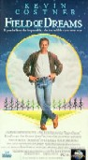
American Rhetoric: Movie Speech
"Gladiator" (2000)

General Maximus Meridius: Opening Battle Address to the Roman Cavalry
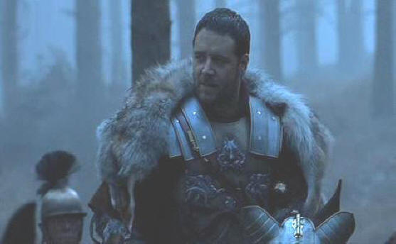
Fratres! [Brothers]
Three weeks from now I will be harvesting my crops.
Imagine where you will be, and it will be so.
Hold the line!
Stay with me!
If you find yourself alone,
riding in green fields with the sun on your face,
do not be troubled --
for you are in Elysium,
and you're already dead!
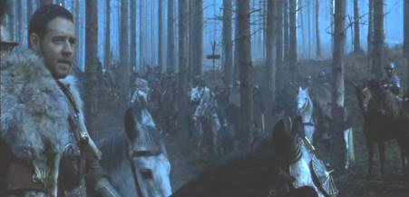
Brothers, what we do in Life echoes in Eternity....



American Rhetoric: Movie Speech
"Henry V" (1989)

King Henry V: St. Crispin's Day Speech, Pre-Battle of Agincourt
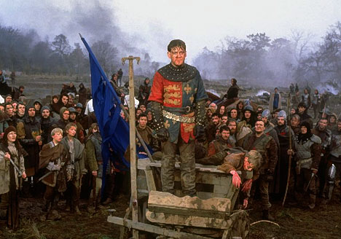

This day is called the feast of Crispian:
He that outlives this day, and comes safe home,
Will stand a tip-toe when this day is named,
And rouse him at the name of Crispian.
He that shall see this day and live old age,
Will yearly on the vigil feast his neighbours,
And say 'To-morrow is Saint Crispin's:'
Then will he strip his sleeve and show his scars.
And say 'These wounds I had on Crispin's day.'
Old men forget: yet all shall be forgot,
But he'll remember with advantages
What feats he did that day: then shall our names.
Familiar in their mouths as household words
Harry the king,
Bedford and Exeter,
Warwick and Talbot,
Salisbury and Gloucester,
Be in their flowing cups freshly remember'd.

This story shall the good man teach his son;
And Crispin Crispian shall ne'er go by,
From this day to the ending of the world,
But we in it shall be remember'd;

We few, we happy few, we band of brothers;
For he to-day that sheds his blood with me
Shall be my brother; be he ne'er so vile,
This day shall gentle his condition:
And gentlemen in England now a-bed
Shall think themselves accursed they were not here,
And hold their manhoods cheap whiles any speaks
That fought with us upon Saint Crispin's day.

Note: Fictional speech written by William Shakespeare (1599) in Henry V, Act 4, Scene 3
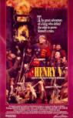

American Rhetoric: Movie Speech
"It's A Wonderful Life" (1946)

George Bailey: Address to the Board of Directors -- Bailey Building and Loan Society
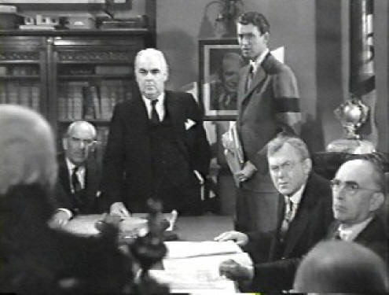
Potter: ...and all because a few starry-eyed dreamers like Peter Bailey stir 'em up and fill their heads with a lot of impossible ideas. Now, I say --
Bailey: Just a minute – just a minute. Now, hold on, Mr. Potter. Just a minute. Now, you're right when you say my father was no business man. I know that. Why he ever started this cheap, penny-ante Building and Loan, I'll never know. But neither you nor anybody else can say anything against his character, because his whole life was -- Why, in the twenty-five years since he and Uncle Billy started this thing, he never once thought of himself. Isn't that right, Uncle Billy? He didn't save enough money to send Harry to school, let alone me. But he did help a few people get outta your slums, Mr. Potter. And what's wrong with that? Why -- here, you're all businessmen here. Don't it make them better citizens? Doesn't it make them better customers?
You, you said that they -- What'd you say just a minute ago? They had to wait and save their money before they even thought of a decent home. Wait? Wait for what?! Until their children grow up and leave them? Until they're so old and broken-down that -- Do you know how long it takes a working man to save five thousand dollars? Just remember this, Mr. Potter, that this rabble you're talking about, they do most of the working and paying and living and dying in this community. Well, is it too much to have them work and pay and live and die in a couple of decent rooms and a bath? Anyway, my father didn't think so. People were human beings to him, but to you, a warped, frustrated old man, they're cattle. Well, in my book he died a much richer man than you'll ever be.
Potter: I'm not interested in your book. I'm talkin' about the Building and Loan.
Bailey: I know very well what you're talking about. You're talking about something you can't get your fingers on, and it's galling you. That's what you're talking about, I know. Well...I've said too much. I -- You're the Board here. You do what you want with this thing. There's just one thing more, though. This town needs this measly one-horse institution if only to have some place where people can come without crawling to Potter. Come on, Uncle Billy!
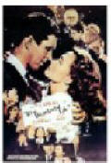

American Rhetoric: Movie Speech
"Saving Private Ryan" (1996)

General George C. Marshall Reads Abraham Lincoln's Letter
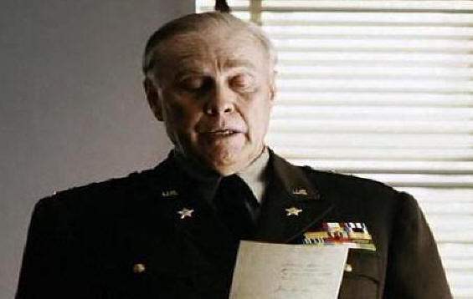

Marshall: I have a letter here, written a long time ago to a Mrs. Bixby in Boston. So bear with me.
Dear Madam,
I have been shown in the files of the War Department a statement of the Adjutant General of Massachusetts that you are the mother of five sons who have died gloriously on the field of battle.
I feel how weak and fruitless must be any word of mine that should attempt to beguile you from the grief of a loss so overwhelming. But I cannot refrain from tendering to you the consolation that may be found in the thanks of the Republic they died to save.
I pray that our Heavenly Father may assuage the anguish of your bereavement, and leave you only the cherished memory of the loved, lost, and the solemn pride that must be yours to have laid so costly a sacrifice upon the altar of freedom.
Yours, very sincerely and respectfully, Abraham Lincoln
The boy's alive. We are going to send someone to find him.
And we are going to get him the hell out of there.
Staff: Yes, sir....
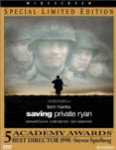

American Rhetoric: Movie Speech
"Saving Private Ryan" (1998)

Captain John Miller: Address to unit on saving Private Ryan
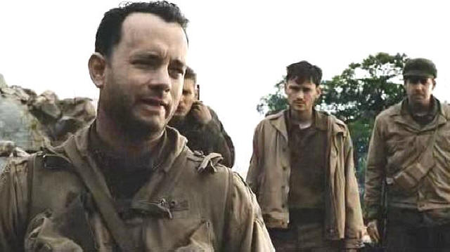

Private Reiben: Well put your money where your mouth is and do it! Do it! Pull the trigger already!
Sergeant Horvath: You don't know when to shut up. You don't know how to shut up.
Corporal Upham: Captain, please!
Captain Miller: Mike? What's the pool on me up to right now? What's it up to? What is it three hundred dollars -- is that it? Three hundred? I'm a school teacher. I teach English Composition in this little town called Addley, Pennsylvania. The last eleven years, I've been at Thomas Alva Edison High School. I was coach of the baseball team in the springtime.
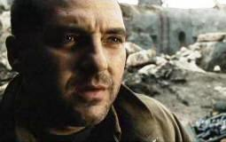
Sergeant Horvath: I'll be doggone.
Captain Miller: Back home when I tell people what I do for a living, they think, well, that, that figures. But over here its a big, a big mystery. So I guess I've changed some. Sometimes I wonder if I've changed so much my wife is even gonna to recognize me whenever it is I get back to her -- and how I'll ever be able to tell her about days like today.
Uh, Ryan -- I don't know anything about Ryan. I don't care. Man means nothin' to me. It's just a name. But if -- you know -- if going to Ramel and finding him so he can go home -- if that earns me the right to get back to my wife -- well, then, then that's my mission.
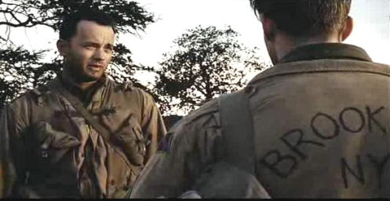
You wanna leave? You wanna go off and fight the war? Alright. Alright, I won't stop you. I'll even put in the paperwork. I just know that every man I kill the farther away from home I feel.

American Rhetoric: Movie Speech
"The Lord of the Rings: The Return of the King" (2003)

King Aragorn: Battle Speech at the Black Gate
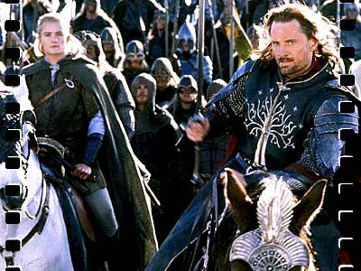

Aragorn:
Hold your ground! Hold your ground.
Sons of Gondor, of Rohan, my brothers,
I see in your eyes the same fear that would take the heart of me.
A day may come when the courage of men fails,
when we forsake our friends
and break all bonds of fellowship,
but it is not this day.
An hour of wolves and shattered shields,
when the age of men comes crashing down,
but it is not this day.
This day we fight!
For all that you hold dear on this good Earth,
I bid you stand, Men of the West!!
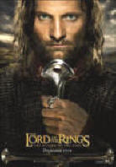

American Rhetoric: Movie Speech
"The Shawshank Redemption" (1994)

The Trial of Andy Dufresne: The District Attorney Cross Examines Dufresne
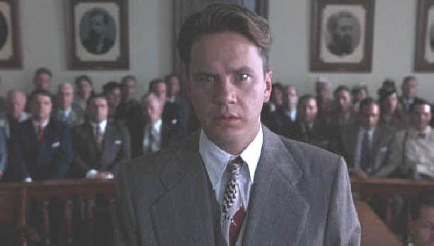

District Attorney: Mr. Dufresne, describe the confrontation you had with your wife the night she was murdered.
Dufresne: It was very bitter. She said she was glad I knew, that she hated all the sneaking around. She said she wanted a divorce in Reno.
District Attorney: What was your response?
Dufresne: I told her I would not grant one.
District Attorney: "I'll see you in hell before I see you in Reno." Those were the words you used, Mr. Dufresne, according to the testimony of your neighbors.
Dufresne: If they say so. I really don't remember. I was upset.
District Attorney: What happened after you argued with your wife?
Dufresne: She packed a bag -- she packed a bag to go and stay with Mr. Quentin.
District Attorney: Glenn Quentin, golf pro at the Snowed-In Hills Country Club, the man you recently discovered was your wife's lover. Did you follow her?
Dufresne: Went to a few bars first. Later I drove to his house to confront him. They weren't home, so I parked in the turn-out and waited.
District Attorney: With what intention?
Dufresne: I'm not sure. I was confused, uh, drunk. I think mostly I wanted to scare them.
District Attorney: When they arrived, you went up to the house and murdered them.
Dufresne: No. I was sobering up. I got back in the car and I drove home to sleep it off. Along the way, I stopped and I threw my gun into the royal river. I feel I've been very clear on this point.
District Attorney: Well where I get hazy is where the cleaning woman shows up the following morning and finds your wife in bed with her lover riddled with 38 caliber bullets. Now, does that strike you as a fantastic coincidence, Mr. Dufresne, or it just me?
Dufresne: Yes, it does.
District Attorney: Yet you still maintain that you threw your gun into the river before the murders took place. That's very convenient.
Dufresne: It's the truth.
District Attorney: The police dragged that river for three days and nary a gun was found. So there could be no comparison made between your gun and the bullets taken from the blood-stained corpses of the victims. And that, also, is very convenient, isn't it, Mr. Dufresne.
Dufresne: Since I am innocent of this crime, sir, I find it decidedly inconvenient that the gun was never found.
Presiding Judge: [Sentencing phase] You strike me as a particularly icy and remorseless man, Mr. Dufresne. It chills my blood just to look at you. By the power vested in me by the State of Maine, I hereby order you to serve two life sentences back-to-back, one for each of your victims. So be it!
American Rhetoric: Movie Speech
"To Kill A Mockingbird" (1962)

Atticus Finch delivers his Closing Argument at the Trial of Tom Robinson
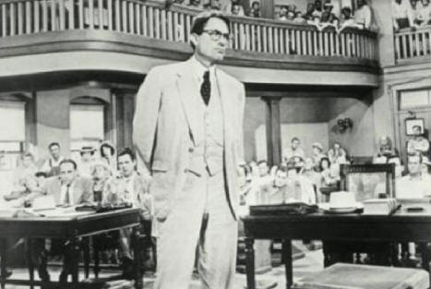
Finch: To begin with, this case should never have come to trial. The State has not produced one iota of medical evidence that the crime Tom Robinson is charged with ever took place. It has relied instead upon the testimony of two witnesses whose evidence has not only been called into serious question on cross examination, but has been flatly contradicted by the defendant. Now there is circumstantial evidence to indicate that Mayella Ewell was beaten, savagely by someone who led, almost exclusively, with his left [hand]. And Tom Robinson now sits before you, having taken "The Oath" with the only good hand he possesses -- his right.
I have nothing but pity in my heart for the Chief Witness for the State. She is the victim of cruel poverty and ignorance. But, my pity does not extend so far as to her putting a man's life at stake, which she has done in an effort to get rid of her own guilt. Now I say "guilt," gentlemen, because it was guilt that motivated her. She's committed no crime. She's merely broken a rigid and time-honored code of our society, a code so severe that whoever breaks it is hounded from our midst as unfit to live with. She must destroy the evidence of her offense. But, what was the evidence of her offense? Tom Robinson, a human being. She must put Tom Robinson away from her. Tom Robison was to her a daily reminder of what she did. Now what did she do? She tempted a negro. She was white and she tempted a negro. She did something that in our society is unspeakable: She kissed a black man. Not an old uncle, but a strong, young negro man. No code mattered to her before she broke it, but it came crashing down on her afterwards.
The witnesses for the State, with the exception of the sheriff of Lincoln county, have presented themselves to you gentlemen -- to this Court -- in the cynical confidence that their testimony would not be doubted; confident that you gentlemen would go along with them on the assumption, the evil assumption, that all negroes lie; all negroes are basically immoral beings; all negro men are not to be trusted around our women -- an assumption that one associates with minds of their caliber, and which is in itself, gentlemen, a lie -- which I do not need to point out to you.
And so, a quiet, humble, respectable negro, who has had the unmitigated temerity to feel sorry for a white woman, has had to put his word against two white peoples. The defendant is not guilty. But somebody in this courtroom is.
Now, gentlemen, in this country our courts are the great levelers. In our courts, all men are created equal. I'm no idealist to believe firmly in the integrity of our courts and of our jury system. That's no ideal to me. That is a living, working reality! Now I am confident that you gentlemen will review without passion the evidence that you have heard, come to a decision, and restore this man to his family. In the name of God, do your duty. In the name of God, believe Tom Robinson.

American Rhetoric: Movie Speech
"We Were Soldiers" (2002)

Lieutenant Colonel Harold "Hal" G. Moore: Address to the 7th Cavalry
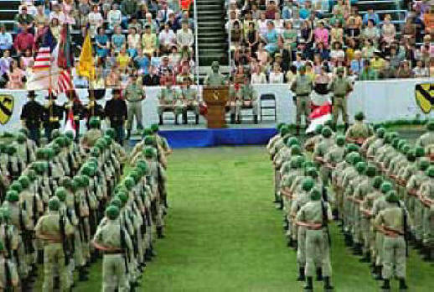

Moore: Look around you. In the 7th Cavalry, we got a Captain from the Ukraine. Another from Puerto Rico. We've got Japanese, Chinese, Blacks, Hispanics, Cherokee Indians, Jews and Gentiles -- all Americans. Now here in the States, some men in this Unit may experience discrimination because of race or creed. But for you and me now, all that is gone. We're moving into the 'valley of the shadow of death' -- where you will watch the back of the man next to you, as he will watch yours. And you won't care what color he is or by what name he calls God.
They say we're leavin' home. We're goin' to what home was always supposed to be. So let us understand the situation. We are goin' into battle against a tough and determined enemy. I can't promise you that I will bring you all home alive. But this I swear before you and before Almighty God: That when we go into battle, I will be the first to set foot on the field, and I will be the last to stop off. And I will leave no one behind. | 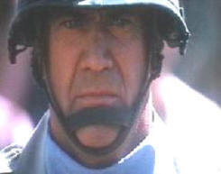
Dead or alive, we will all come home together. | So help me God.

